Issue #126

CALENDAR OF EVENTS…

Town Board Meetings are held on the second
Tuesday of each month. All meetings are held in the Silver Cliff Town Hall at 7:00 PM.

Garbage Pickup is every Wednesday until December 1st. It will then be picked up on the first, third and fifth Wednesday until April when it goes back to every week.

NEW RECYLING HOURS
Starting in October the first and third Sunday hours will be 8:000AM – 12:00 The second and fourth Wednesday they will be 8:00 am - 11:00.

For questions on the above items or any other town business, contact your town supervisor. They both can address any issues for the Town of Silver Cliff.

Questions or concerns for the Constable, call Sabin Rosenbaum at 715-927-3132.

The American Legion and Legion Auxiliary meet at the Town Hall on the first Saturday of each month at 10:00 AM

THE FIRE AND RESCUE AUXILIARY meet on the second Monday of each month at the Town Hall at 9:00 AM starting in April. All women in the area are encouraged to attend. The Comprehensive Planning Commission meets at the Town Hall on

November 2025

The Comprehensive Planning Commission meets at the Town Hall

The Fire Department meets on the first and third Tuesday of each month at 6:00 PM in the Fire and Rescue Building.

Town Clerk
Lisa Weinrich
Town of Silver Cliff
N11929 County I
Silver Cliff WI 54104
715-757-3163
clerk@silvercliffwi.com

Jane Meissner
715-245-1708
nebuildinginspector@gmail.com

Road Crew Foreman
Jeff DeBauche
725-757-3130
townshop@silvercliffwi.com

GET WELL WISHES….

SINCERE SYMPATHY
Again, we apologize if we missed anyone. Sometimes people let us know of those who are not feeling well or who passed away. If you know of someone that we should be thinking about, please let us know and we will add them to the list. Thank you.

AMERICAN LEGION POST/UNIT 66 November 2025 NEWSLETTER

Post Cmdr. Chuck Cable 715-757-9400
Post Vice Cmdr. Peter Schlaikowski 414-587-1325
Unit 66 Pres. Dee Farley 715-757-3922 or 920-810-2664.

The American Legion Post 66 and American Legion Auxiliary Unit 66 continue to meet together on the first Saturday of each month at the Silver Cliff Town Hall during the winter months and at Silver Cliff Memorial Park during fair weather months This has worked well for us as many of our activities are shared events. Contact any member or officer of the Post /Unit 66 for information on joining our great organization.
The 2025 Chili Fest was September 27th. The proceeds from the Chili Fest are used for local student scholarships. Post 66 and Unit 66 both require each student to attend a minimum of one semester of secondary schooling to maintain their
eligibility for a scholarship. There are other requirements that are specific to each organization.
The applications for the 2026 Scholarships will be available in early spring of 2026. All scholarships are $1000.00 per student per student. The American Legion Auxiliary Unit 66 will be awarding $1000.00 to Lydia Schaal in December.

Each year at the Chili Fest, we also have a Soup Contest. There usually are between fifteen and twenty participants in the contest. This event raises enough money to support one of the scholarships we present to local students.

At the November 11th Veterans Day Celebration held at Wausaukee Schools, the American Legion Post 66 was in attendance along with other area Veterans. Post 66 Member Bill Woger called cadence for the Wausaukee School Color Guard. It was very nicely done celebration. The entire school was in attendance as well as other local residents.

On Sunday, December 7th, the Post & Unit 66 will be having their Annual Christmas Dinner at Rene’s Dining Room. As we have done in the past, we will be collecting non-perishable items to be donated to a local food pantry. This year the collected items
will be giving to Pastor Fred’s Food Pantry in Amberg.

On December 8th, American Legion Auxiliary Unit
66 Members Dee Farley, Ann Wender and Barb Van Boxtel will be going to the Oscar G. Johnson
Veterans Facility in Iron Mountain to meet with the American Legion State Delegation. Ann and Barb spend many hours each month volunteering at the facility. Many Marinette County Veterans go to the Iron Mountain Veterans Facility for their medical care.
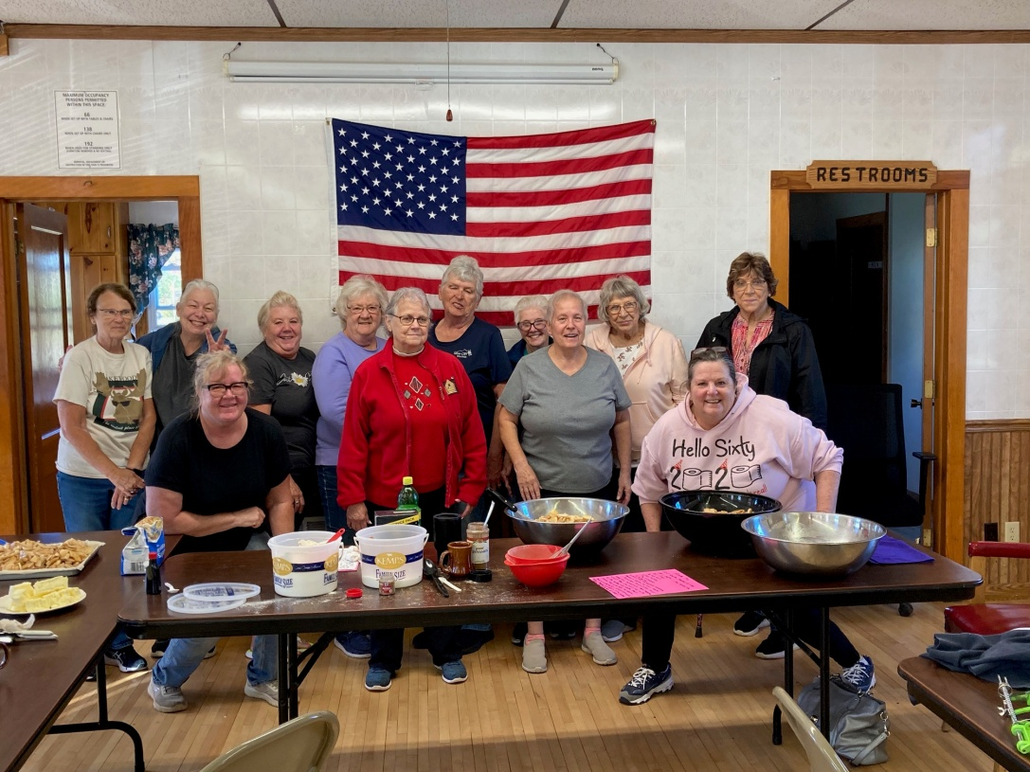

Chili Fest Pie Makers for 2025 Event
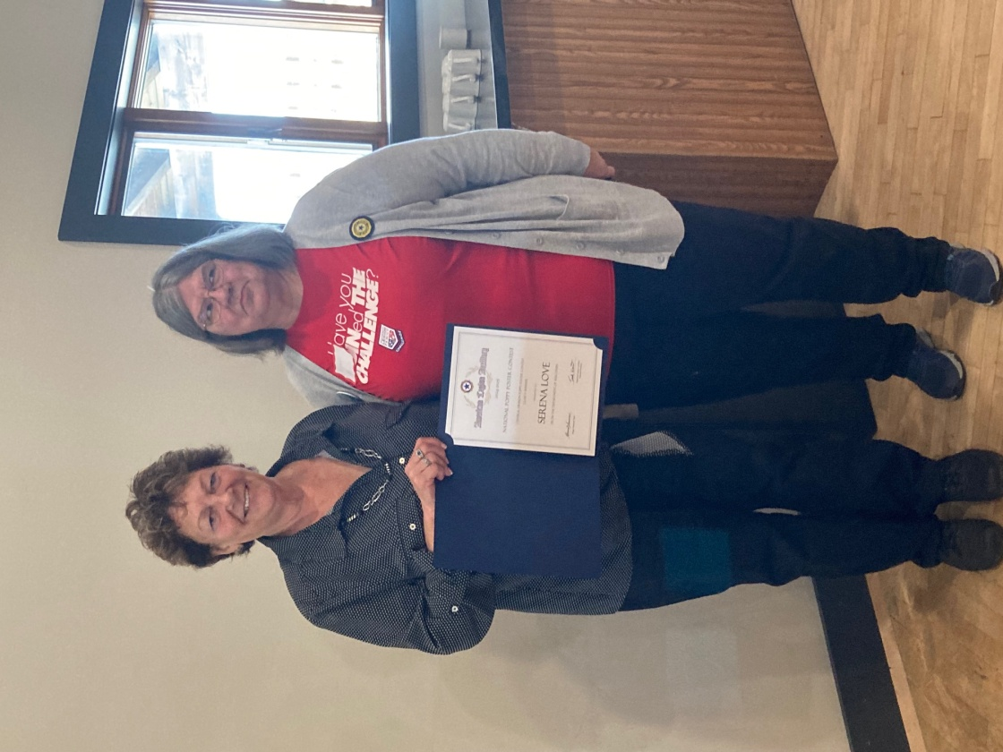

WI Dept. Pres Becky Mueller presents award for National Poppy Poster winner Serena Love

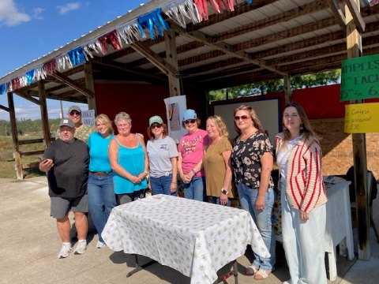

2025 Soup Contest Chairman and judges. Good job by all!

Silver Cliff Fire and Rescue Auxiliary
The Silver Cliff Fire and Rescue Auxiliary is here for our community in so many ways. In August we hold our Annual SCFR Auxiliary Parade with those proceeds going to fund both the College Scholarships we offer to the children of Silver Cliff Residents, also host the Deer Hunter’s Bake Sale in November, and in December the Children’s Party for children ages 10 and under of Silver Cliff and now Athelstane residents. We also reach out to residents who have suffered from illness or loss through our Sunshine Committee, we offer assistance for those residents in need, and we offer Funeral Dinners for residents at little to no cost.

October meeting, we discussed our upcoming events. We did not have enough members present for a quorum so no voting took place but we did have a very productive discussion and several 0ptions for the Deer Hunter’s Bake Sale and the Children’s Christmas were reviewed.

At the October Town Board meeting the SCFR Auxiliary was presented with a check from Charles
‘’Charlie” Collins estate in the sum of 10,000 to be used for the children’s Christmas party and for education.

To both Charle and his brother Bob Collins Please accept our Heart Felt THANK YOU

November meeting is our Annual Pot Luck Luncheon that we host for our members, our Parade Grand Marshalls. This year it was Bruce and Annita Weber. We were able also to present our check for a percentage of the proceeds from our annual picnic going to the Silver Cliff Fire and Silver Cliff Fire and Rescue which was accepted
by Chief Al Walesh, Assistant Chief Jeff DeBauche, and Ann Wender.

We enjoyed a great luncheon and then went back to business. There was a question about having the Deer Hunters Bake Sale at Jungle Jims for several reasons, one was due to new ownership change and the other was complaints we have been hearing that no one is utilizing the Community Center as a viable resource for such an event.
After discussion we determined that the Deer Hunters Bake Sale would be held at Jungle Jims along with the number of volunteers needed, we also determined that we would take goods in at the
Community Center the night before the bake sale.
This was something that Jungle Jims did for us but due to the new ownership space was not available for that so we had to transport the goodies in the morning of the bake sale. We also discussed how we planned the menu for the Christmas Party this year and a lengthy discussion about the generous donation from the Charlie Collins estate. A couple
suggestions were that we possibly put together a book nook at the community center for kids to do a book exchange in addition to possibly having an Easter Party next spring. We also held elections for the office of President and Secretary, election results; President Theresa Habeck and Secretary Dee Farley.

Normally we would have had the November meeting as our last for the year until next April but there are a few things that need to be discussed so we may end having a few meetings during our downtime. We meet 2nd Monday of the month beginning in April.

Silver Cliff News Items from Silver Cliff Rescue Squad

The winners of the monthly drawings are listed below. Each #1 name won $50 and each # 2 or #3 name won $25.00.

Congratulations to all the winners. We would like to thank those people who support this drawing.

August 1- Tina Lardinois of Suamico
2 – Tim Jaworski of Silver Cliff
3- Ken Jacobs of Wabeno

Sept. 1 – Kelly Barnes of Athelstane
2 – Steve Wender
3 - Robert Ploeckelman of Porterfield

Oct 1 – Terri Sot of Green Bay
2- Gail Van Ark of Silver Cliff
3 - Gail Van Ark of Silver Cliff

Nov 1 - Jim Lesperance
2- Kelly Kitchmaster
3 – Jim Lesperance

Watch out for the black ice that comes with the beginning of snow and please be careful

We wish you the happiest, healthiest, and safest of Holidays.

LOOKING for NEW newsletter ads. Only $30.00 per year.

This will keep the newsletter coming to your mailbox.

Barb Van Boxtel by November 16th. My phone number is: 920-676-9810.
Pick up one of the newsletters at one of the businesses. If you would like a copy in the mail, please call or send us your address. We will be glad to add you to our mailing list. There is no cost but donations are always
welcomed.

WE ARE NOW OFFERING OUR NEWSLETTER AT: WWW.SILVERWI.COM

.

